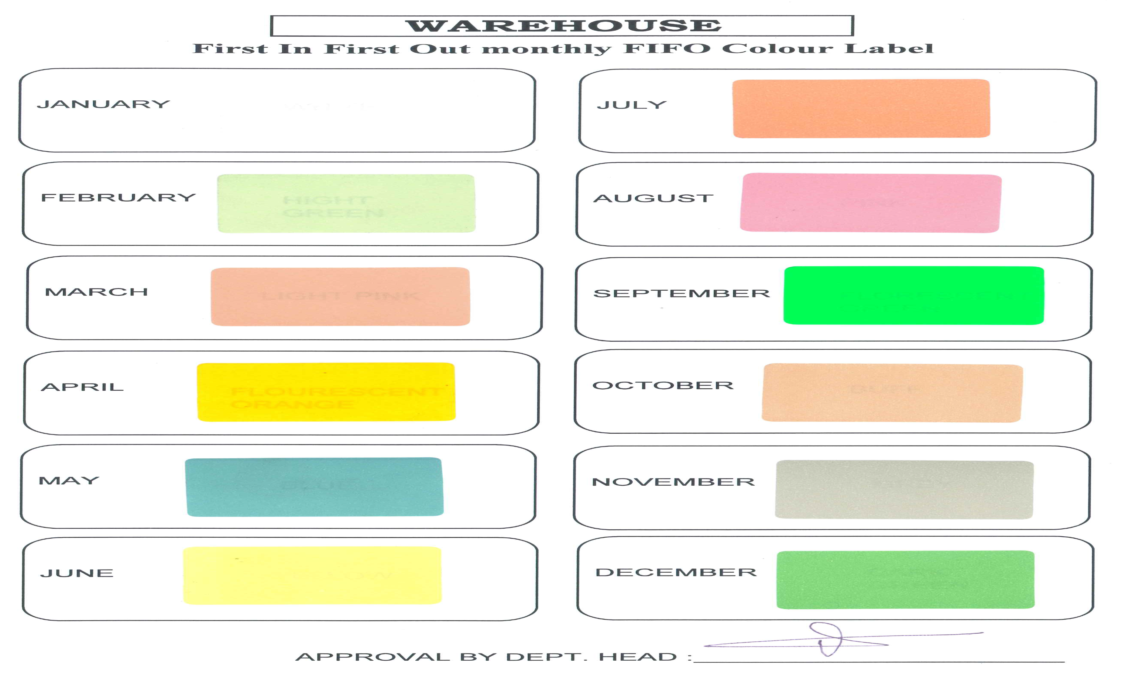

FLX-001 Rev 0.0 Dated 2nd Nov 2011